ECS 1 Supply list
2023-2024 school year

1” Binder (1 blue, one white) | 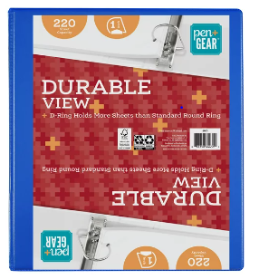
White Card Stock, 8.5" x 11", 199 GSM, 150 Sheets | 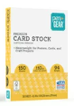
Hand sanitizer | 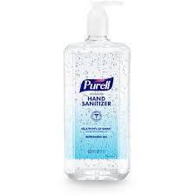
Tissue | 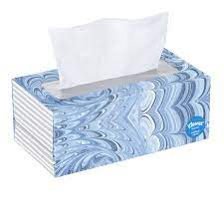
Baby wipes | 
Magic Erasers | 
3 packs Dry Erase markers | 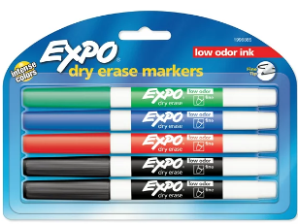
2 packs Vis-à-vis Wet Erase markers | 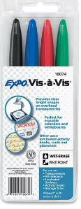
1 Composition notebook | 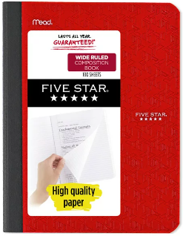
Daily supplies:
1 Bookbag
Change of clothes
Snack Daily
Toileting items if needed (pull-ups & wipes 1 box of gloves size medium)

